HR 2 BREAKDOWN

TEAM: [21Su01-CWC]

Due Date: 11/5/2021

Provide several pics of the current state of your completed system thus far here:

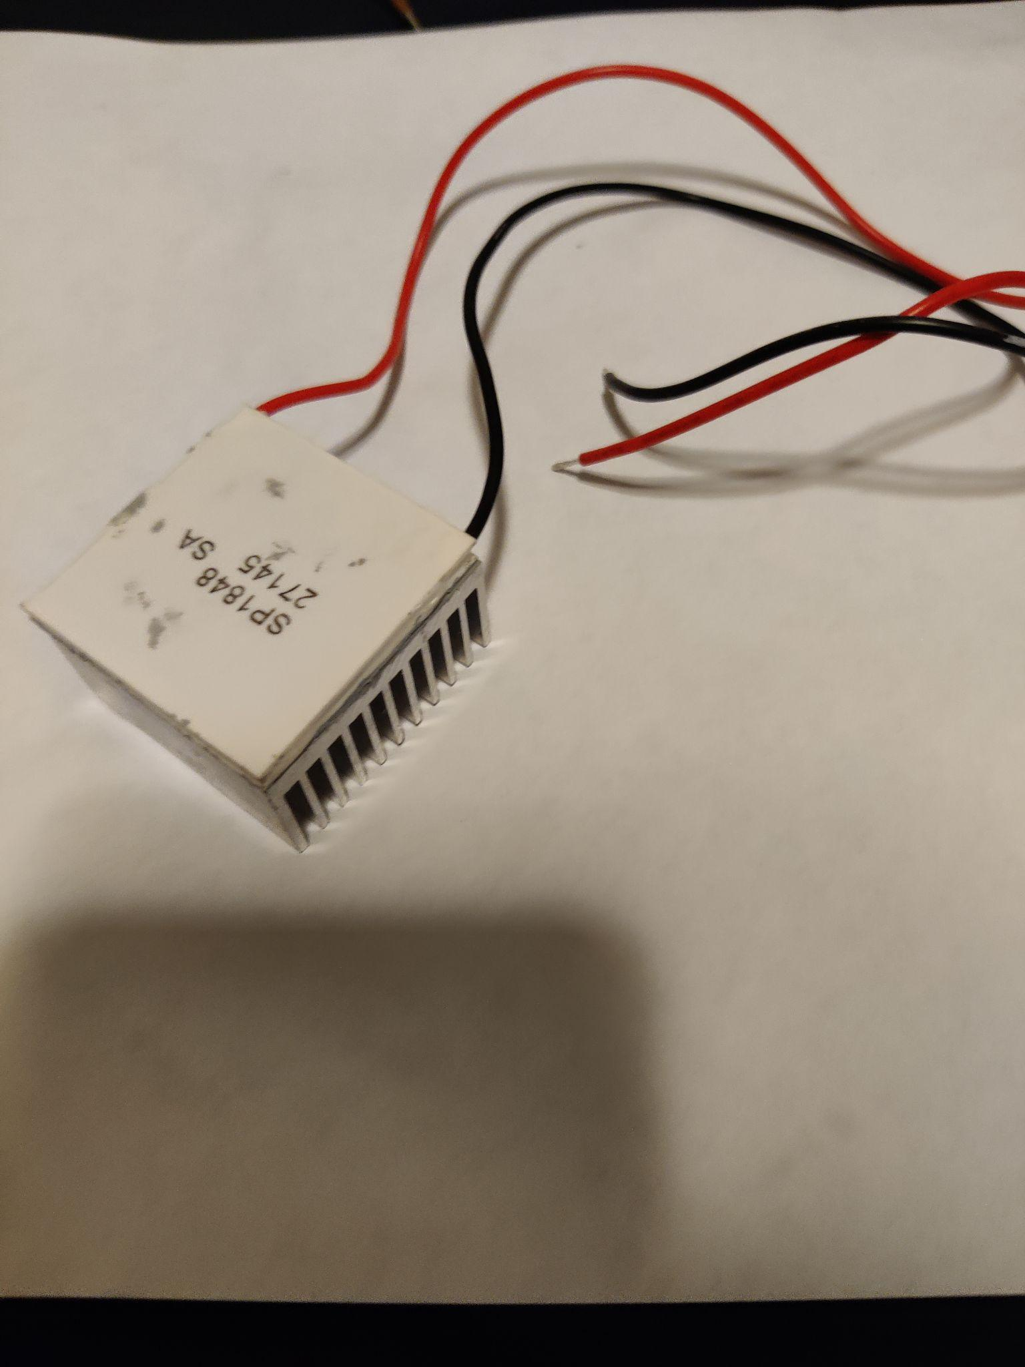
Fig.1
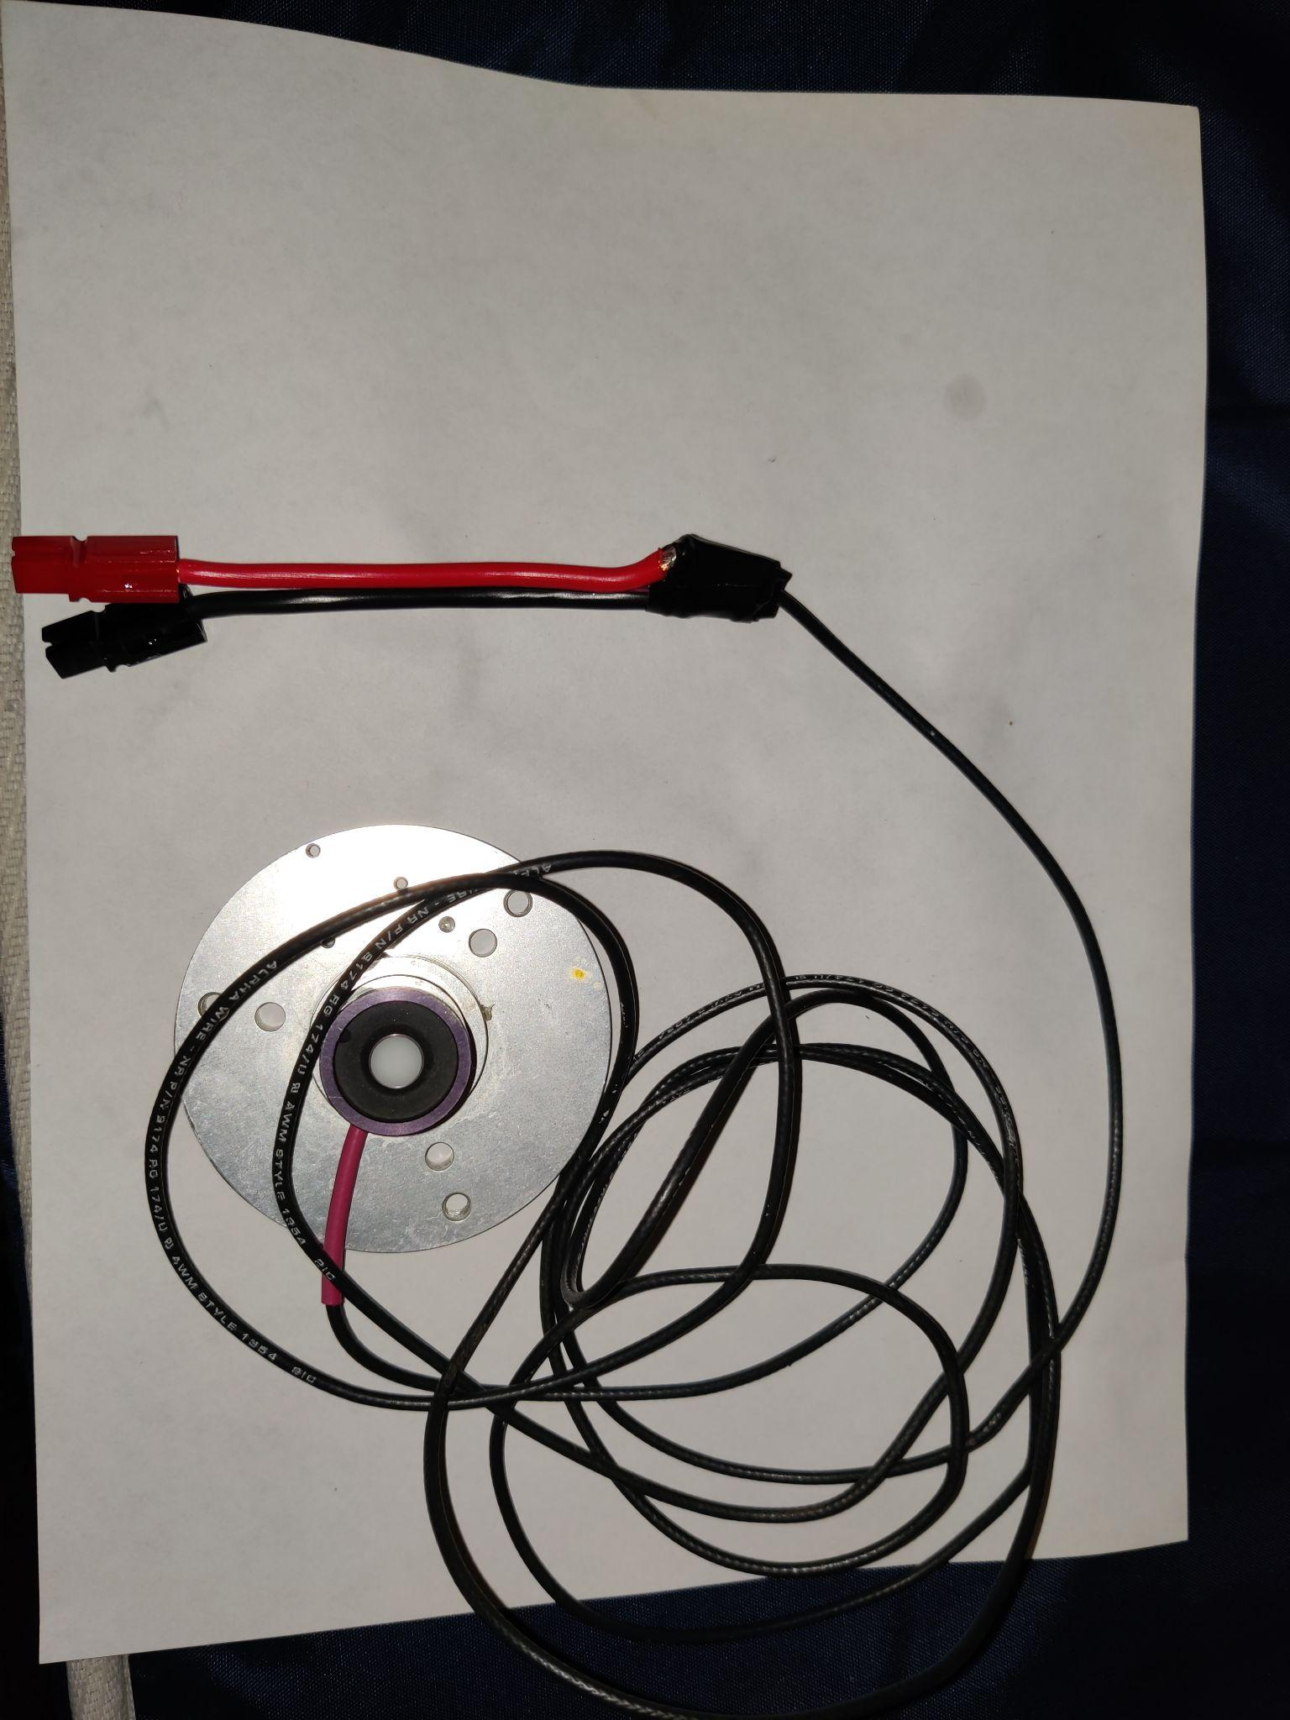
Fig.2
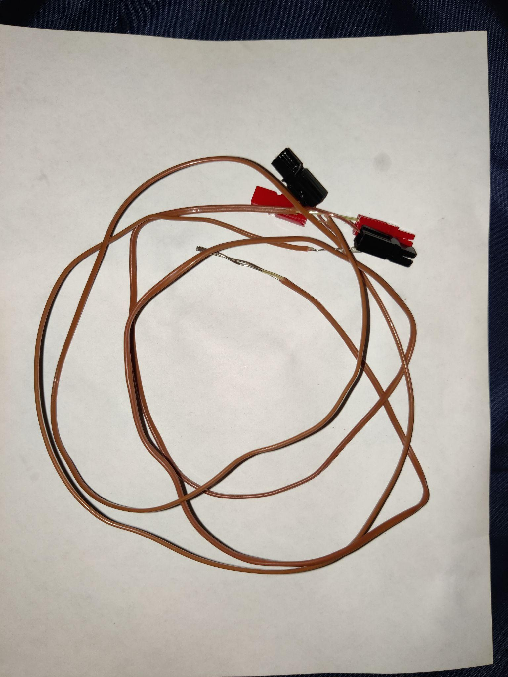
Fig.3
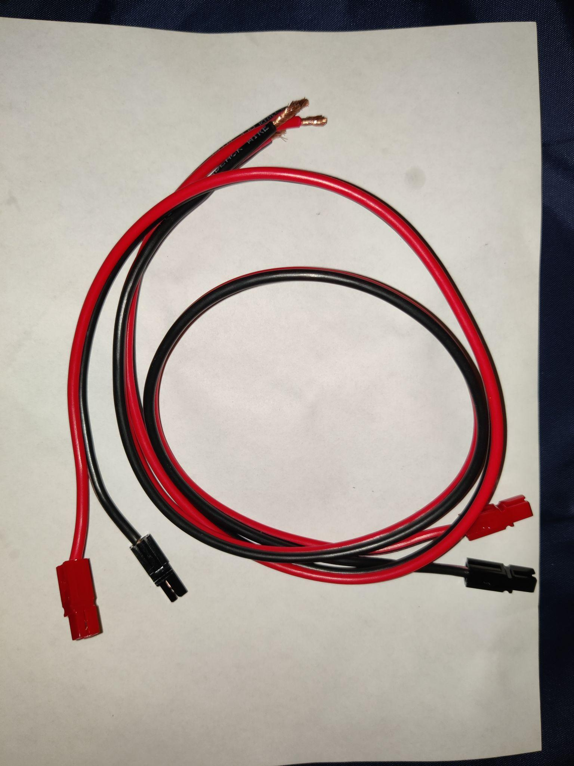
Fig.4
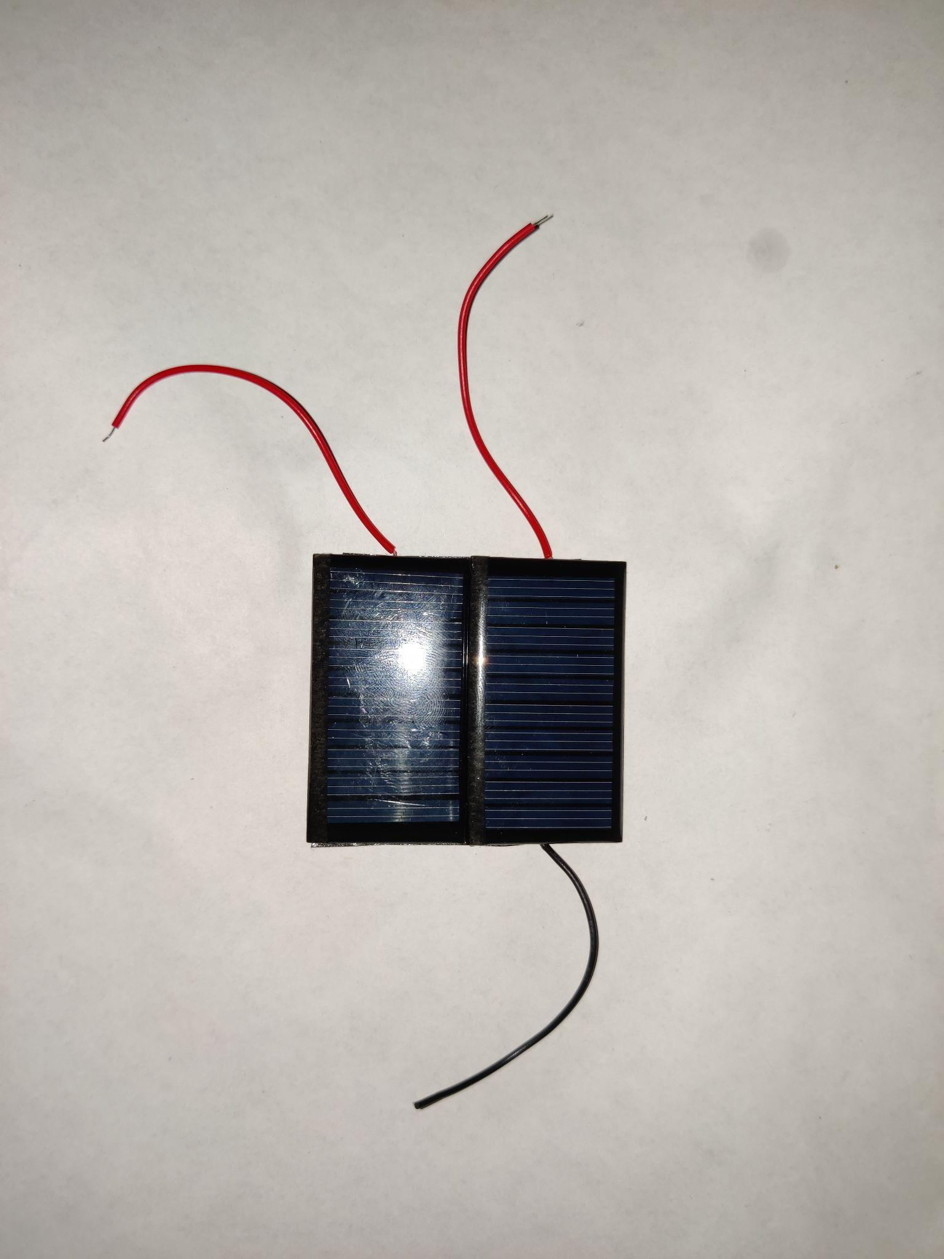
Fig.5
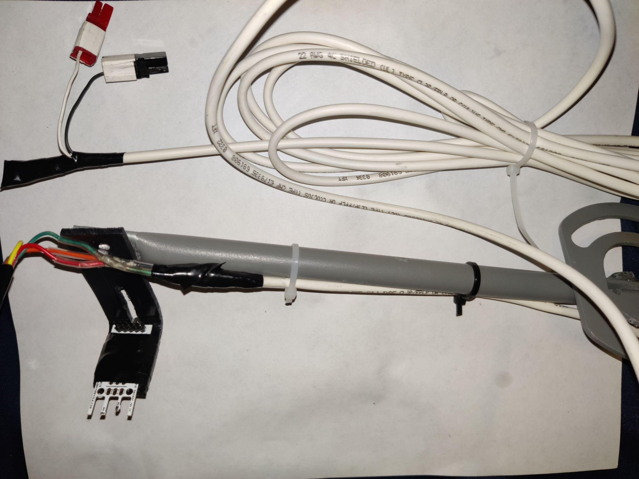
Fig. 6
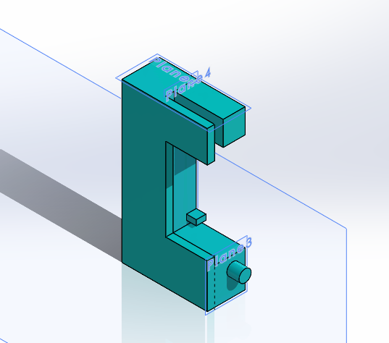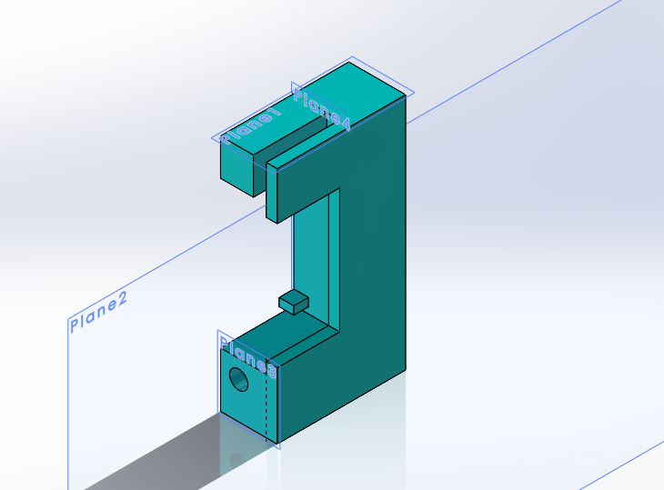
Fig. 7

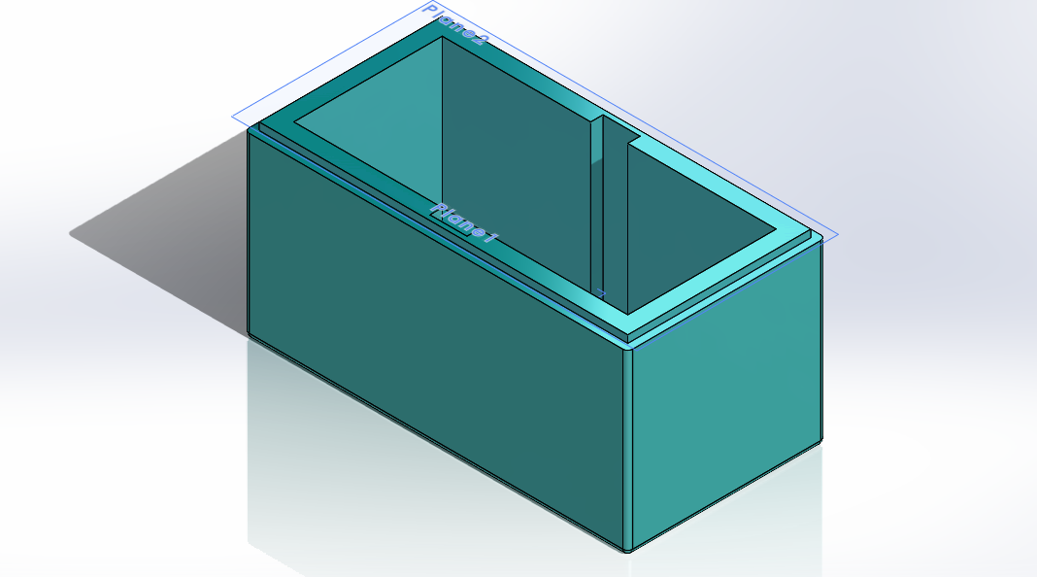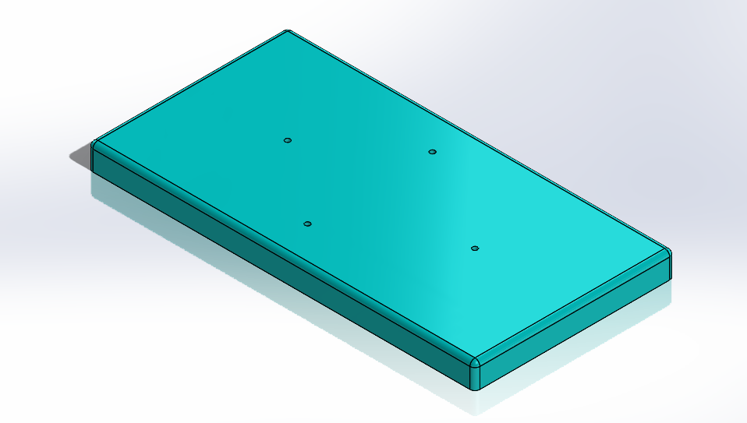
Fig. 8

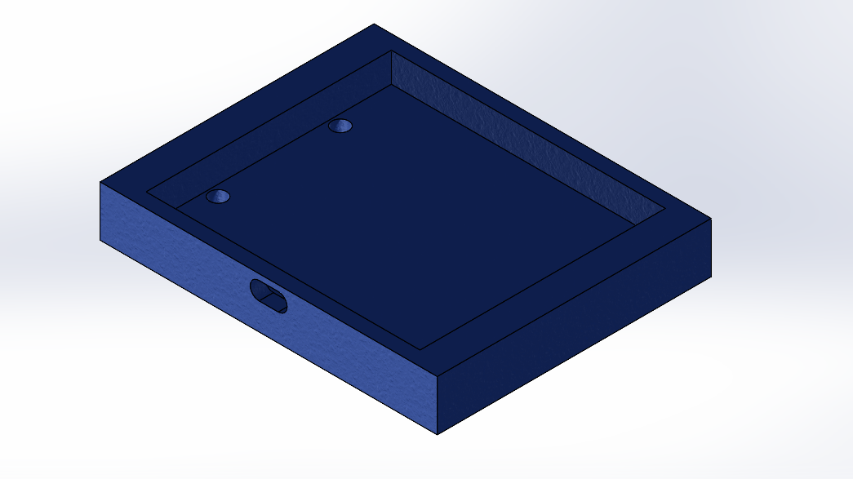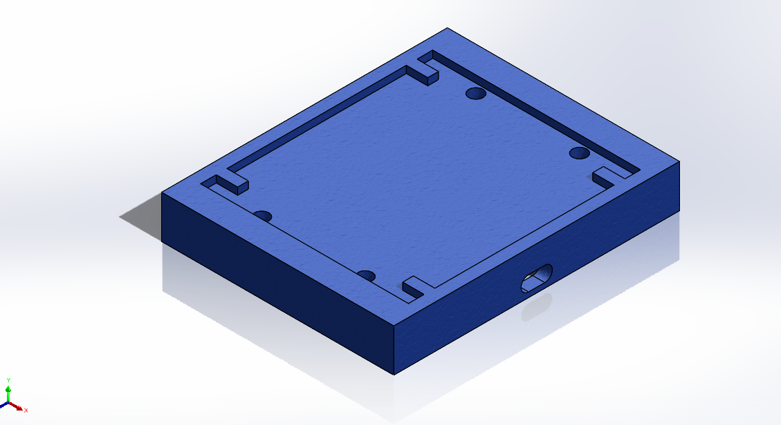
Fig. 9 solar panel sink
The following are the Action Items each person completed between Hardware Review 1 and Hardware Review 2:

Team Member: Yuxuan Gu
Action Item | Date Completed | Result/Proof of Completion
Fixing | 10/26/2021 | Pyranometer (Fig.2)
Soldering | 10/26/2021 | Fig. 1,3,4,5
CAD | 11/2/2021 | Fig. 7&8

Team Member: Yuanhua Zhao
Action Item | Date Completed | Result/Proof of Completion
welding and fixing | 10/26/2021 | wind sensor/solar panels/thermocouple [Figure. 3, 5 and 6]
make CAD of 3D printing | 11/05/2021 | solar panels sink [Figure. ]
programing | 11/01/2021 | Labview Vi

The following are the Action Items for each team member between HR 2 and the Final Product presentation:

Team Member | Action Items | Date Due
Yuxuan Gu | - Improve CAD for 3D printing  - Soldering and building subsystems  - Testing subsystems | - 11/7/2021  - 11/14/2021  - 11/21/2021
Yuanhua Zhao | - 3D printing  - welding solar panel  - programing  - testing | - 11/14/2021  - 11/14/2021  - 11/21/2021  - 11/28/2021

